Project Objective

SPB Metro

This project's purpose is to build a complete map of the Saint-Petersburg metro system that will give users with an efficient tool for navigating the city's large underground network. The app will have a variety of features that will make it simple for users to plan their trips and navigate the city.

One of the application's primary features will be the ability to offer users with step-by-step directions from one station to another, as well as the expected duration and cost of the journey. This will be accomplished through the use of an algorithm.

In addition to providing users with directions, the application will also provide the status of each station. Status will show is station opened or closed. Based on this routes can be changed.

Another important feature of the application will be the ability to view the history of previous journeys, including the route taken, travel times, and cost.

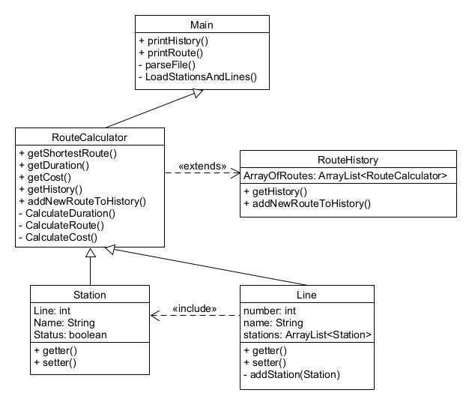

Figure 1: Class diagram for application SPB Metro